Google - compute engine - offer - IaaS (Infrastructure as a Service)

Compute Engine provides maximum flexibility for those who prefer to manage server instances themselves.

GKE (Google Kubernetes Engine) - runs containerized applications in a cloud environment.

App Engine - Fully managed PaaS offering (Platform as a Service)

Bind code to libraries, more focused on application logic

Cloud Functions - Executes code in response to events

Cloud Run -

TPU (Tensor Processing Unit) -

Google cloud ⬇️

* Relational databases
* Non - relational databases
* Worldwide object storage

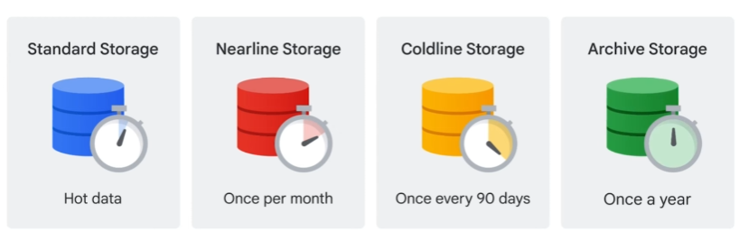

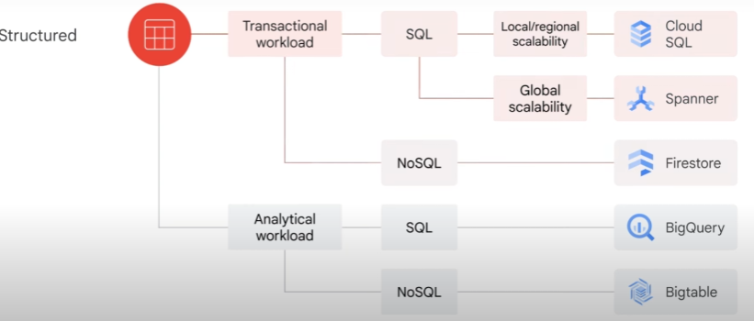

Gojek case study -

First Challenge - Data Latency: Reports we produced one day later, so they couldn’t identify problems immediately.

Dataflow - use for streaming and data processing

BigQuery - use for real-time business insights

Second Challenge - Quickly determining which location had too many, or too few, drivers to meet demand.

Dataflow - Streaming event data pipeline

Driver location to Pub/Sub for every 30 secs. - Dataflow to process the data - Pipeline would aggregate the supply pings from the drivers against the booking requests - Notification This would connect to Gojeks notification system to alert drivers where they should go.

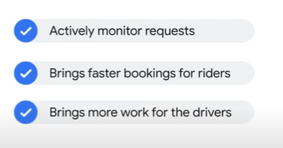

Pub/Sub - Publisher/Subscriber or Publish messages to subscribers

It’s a distributed messaging service that can receive messages from a variety of device streams such as gaming events, IoT devices, and application streams. And offers end to end encryption.

Architecture -

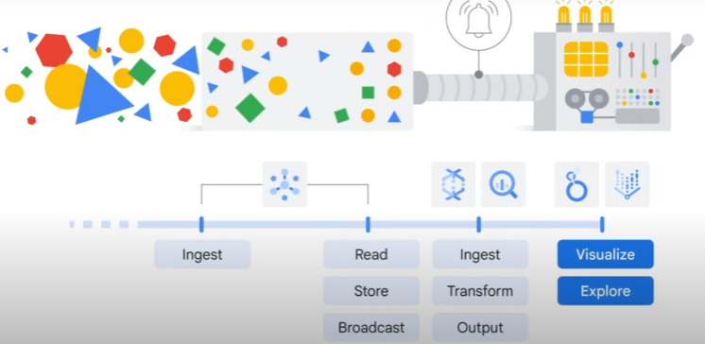

Dataflow -

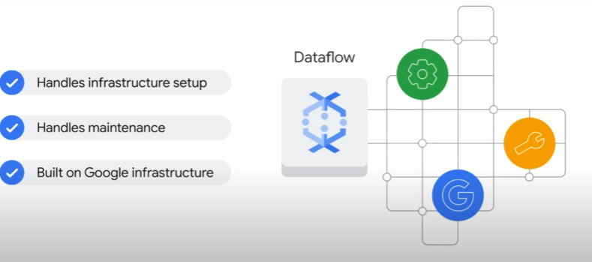

Dataflow is serverless and NoOps and it’s designed for low maintenance.

We don’t need to monitor all of the compute and storage resources that Dataflow manages.

Dataflow templates ⬇️

Streaming ➡️ Streaming - Pub/Sub to BigQuery

Pub/Sub to cloud Storage

Datastream to BigQuery

Pub/Sub to MongoDB

Batch - Big Query to Cloud Storage

Bigtable to Cloud Storage

Cloud Storage to BigQuery

Cloud Spanner to CLoud Storage

Utility - Bulk compression of Cloud Storage files

Firestore bulk delete

File format conversion